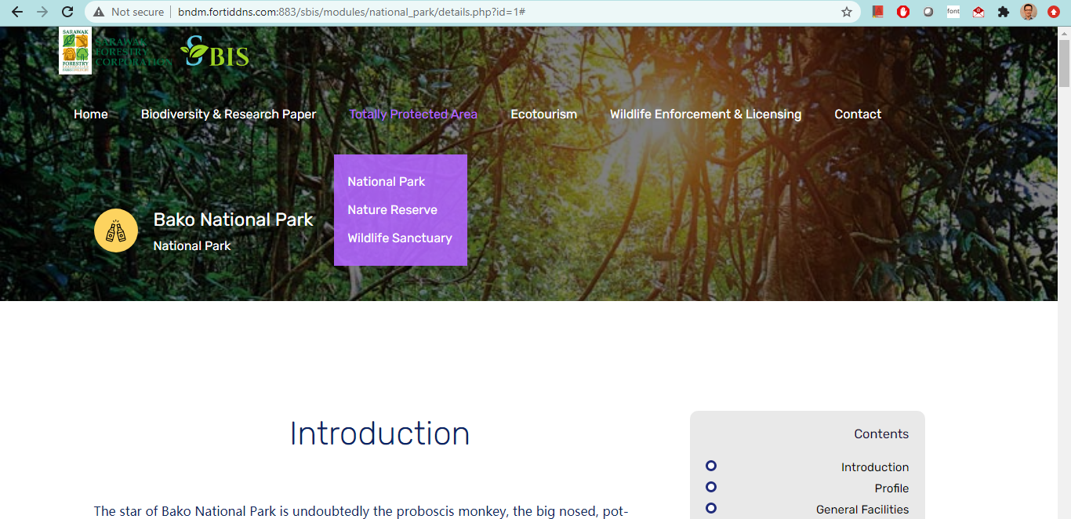
5) Add TPA name or species’ common name as Header
4) gap too big
3) gap too big, adjust near to top menu
1) Can’t see the company name
2) This line drops from the logo level under resolution 1366x768 (100% screen size)

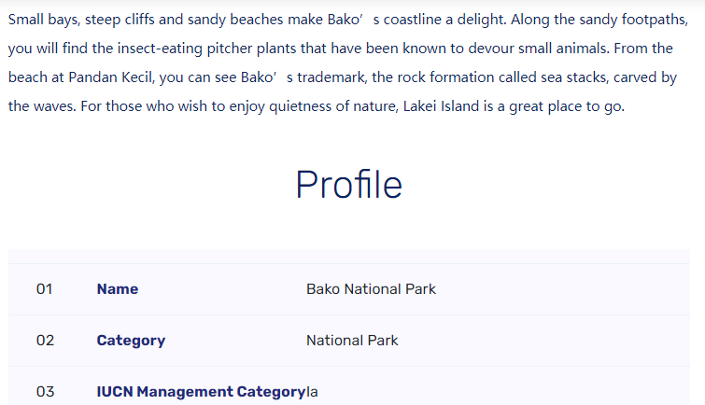
7) gap too big – put same as paragraph
APPLY TO ALL TABLE STYLES
6) gap too big, reduce half
8) border spacing too near for 2 cells
APPLY TO ALL TABLE STYLES

Apply for both TPA and Biodiversity

